**OOP’s Python Assignment**

**5th Feb. 2023**

**Q1. Explain Class and Object with respect to Object-Oriented Programming. Give a suitable example.**

**Sol.** A class is considered as a blueprint of objects. For example, We can think of the class as a sketch of a house. It contains all the details about the floors, doors, windows, etc. Based on these descriptions we build the house. House is the object.

Since many houses can be made from the same description, we can create many objects from a class.

An object is called an instance of a class. For example, suppose car is a class then we can create objects like Car1, Car2, etc from the class.

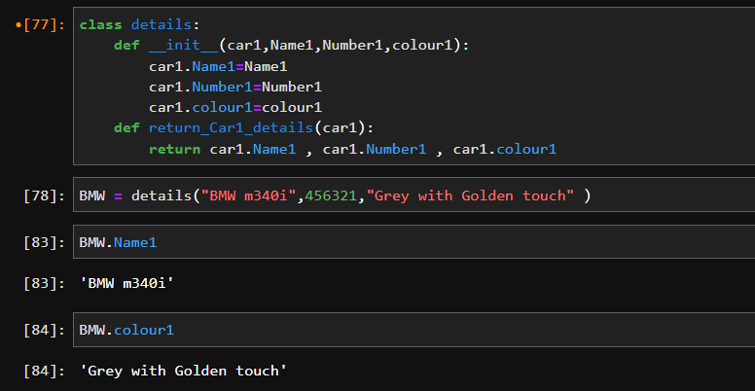

**Q2. Name the four pillars of OOPs.**

**Sol.** Four Pillars of OOPs is,

* Polymorphism
* Inheritance
* Abstraction
* Encapsulation

**Q3. Explain why the __init__() function is used. Give a suitable example.**

**Sol.** __init__ is a special python method that runs whenever a new object is created. These types of functions are used to initialize the attributes of that class, E.g., if the class is Person, then the attributes will be name, age, etc.

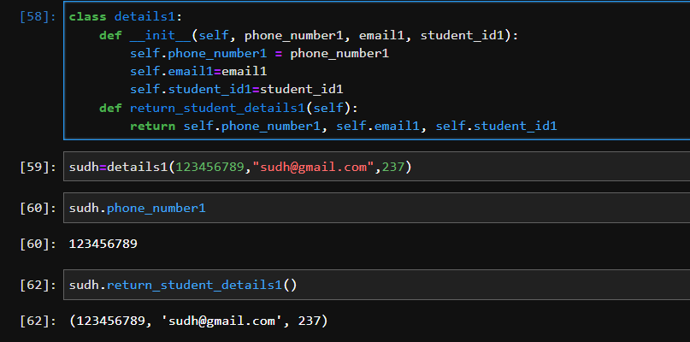

**Q4. Why self is used in OOPs?**

**Sol.** The self is used to represent the [instance](https://www.edureka.co/blog/isinstance-in-python/) of the class. With this keyword, you can access the attributes and methods of the [class in python](https://www.edureka.co/blog/python-class/). It binds the attributes with the given arguments. The reason why we use self is that Python does not use the ‘@’ syntax to refer to instance attributes.

**Q5. What is inheritance? Give an example for each type of inheritance.**

***“This Question is from upcoming topic. so I will do this question in next assignment”***